Contents

1. Introduction 2

1.1 Basis for the project. 2

1.2 Machine Learning 3

1.3 Types of Machine Learning 3

1.3.1 Supervised Learning 4

1.3.2 Unsupervised Learning 4

Difference between unsupervised and supervised learning 5

1.3.3 Reinforcement Learning 5

2 Research into Applications of ML in medicine 6

2.1 Current Applications 6

2.1.1 Epidemic Outbreak Prediction Applications 6

2.1.2 Chatbots 7

2.1.3 Oncology Applications 7

2.1.4 Pathology Applications 7

2.2 Futures Applications 7

2.2.1 Radiology and Radiotherapy Applications 7

2.2.2 Rare Diseases Applications 7

2.3 Obstacles in ML and medicine 8

2.3.1 Data & Regulations 8

3 Information Review 8

4 Development of The Applications. 9

The Process of classification for predictions 9

4.1 Project specifications 9

4.2 Design of my application. 10

Wireframes drawings 11

4.4 Management of the application development stage. 15

4.5 Tools used to develop the project. 15

4.6 Machine learning model frameworks use in the development of the application. 16

4.7 Coding Languages used to develop this application. 16

4.8 Datasets required for the design of this application. 17

5 Research and PDP 17

5.1 Summary of skills/knowledge that where required to be developed/learnt to create this application: 18

5.2 Comparison of the Models created. 20

5.2.1 Test details 20

TensorFlow 20

Core ML 21

5.2.2 TensorFlow Vs. Core ML 22

6 Medical Hub (Main Deliverable) 23

6.1 Home 23

6.2 Injury Drawing 23

6.3 Blood Cell Identification 24

6.4 Hand Bone and injury Identification 24

6.5 Natural Language Processing 24

6.6 Application (Medial HUB) Evaluations 25

7 Critical Reflection 25

7.1 Project & Deliverables 25

7.2 Research 26

7.3 PDP 26

7.4 Success of Deliverables and Future Development 26

8 Conclusion 27

9 References & Appendix 28

9.1 Abbreviation list 28

9.2 Libraries 28

9.3 Lynda.com Courses Links 28

10 Bibliography 29

10.1 Online Recourses 29

10.2 Books 31

10.3 Journal 31

# 1. Introduction

## 1.1 Basis for the project.

Most developing countries have a serious shortage of qualified medical personnel. Particularly of qualified pathologists, which leads to long delays in the testing and the diagnosis of diseases. This in its own leads to needless suffering and unnecessary deaths. A review of literature on the field of ML in medical science shows that ML can partially contribute to correcting this problem. These have been specially designed to allow ML models to work with mobile and portable devices such as the iPhones, iPads and the android equivalents.

The aim of this dissertation is to show the potential and possibility to develop the next stage of software that can be used in the medical field. The use of ML will reduce the need for other resources such as external databases and other heavy tools.

The applications proposed in this project could allow medical professionals such as “Doctors without borders” to test and diagnose patients in field hospitals without having to carry a lot of equipment or have to send blood samples over long distances with related delays and the risk of contamination.

The applications could also be used in developed countries where medical facilities are under pressure. The applications could provide an indication of a disease/illness, saving time and resources.

## 1.2 Machine Learning

Machine Learning (**ML**) was first used in 1959 by a computer scientist named Arthur Samuel, who defined Machine Learning: as the “Field of study that gives computers the ability to learn without being explicitly programmed” (Puget, J. ,2016). While at IBM he developed a program that learnt how to play checkers better than him, using pattern recognition and computational learning using algorithms that he developed which were capable of learning from datasets and could make calculated predictions based on the data. These predictions or decisions are done using instructions that are defined by a model that was created using sample inputs of the types of expected data.

ML has evolved into a subfield of artificial intelligence (AI) (Raschka, S., & Olson, R. 2016), which involves the development and designing of self-learning algorithms, which analyse large pre-determine datasets to help with the development of a model which can be used to make predictions.

Tools such as e-mail spam filters, predictive text, voice recognition, web search engines, optical character recognition (OCR), image recognition and more recently self-driving cars have been developed using ML.

## 1.3 Types of Machine Learning

There are three different types of machine learning; supervised learning, unsupervised learning, and reinforcement learning. A common factor is that all three types require data to learn from.

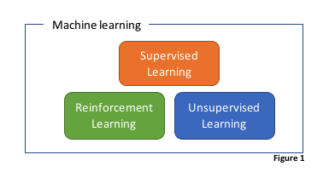

### 

### 1.3.1 Supervised Learning

Supervised learning is a process where an algorithm is used to learn from correctly labelled training data, so that the algorithm is taught to recognises the correct answers. In other words, supervised learning algorithms results are known before the start of the test and that only the correctly labelled data is used for training purposes.  This learning process or tests stop when the algorithm achieves an acceptable level of correct answers (Raschka, S., & Olson, R. 2016).

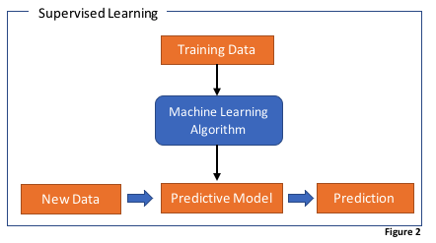A good example to demonstrate supervised learning, in everyday use, would be a model to identify spam within an e-mail filtering system.

### 1.3.2 Unsupervised Learning

In unsupervised learning we are dealing with unlabelled data or data of an unknown structure. The program learns to identify complicated processes and patterns without the benefit of human training. With unsupervised learning algorithms one is unaware of what the outcome will be but will be able to examine the structure of the data that is extracted which will still give meaningful information without the guidance of knowing that the outcome variable should be. Examples of Unsupervised Learning are the Apriori algorithm, K-means. Unsupervised Learning can be extremely complex.

#### Difference between unsupervised and supervised learning

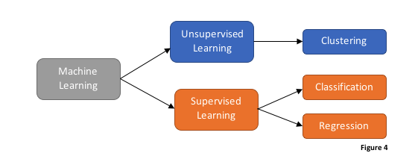

### 

### 1.3.3 Reinforcement Learning

With reinforcement learning the main purpose is to develop a model which can improve its own accuracy and performance each time it interacts with a desired environment. However, it is important in reinforcement learning to remember that the reward signal feedback is not based on a true value but rather on how well the action was measured by the quality of the reward function.

A common example of reinforcement learning is an AI character in a video game. The agent decides on the actions the character should take based on the current situation like a gun fight (Environment), the reward can be identified by the choices taken which may lead to victory or defeat at the end of the gun fight. Each time the agent interacts with the environment it can use the reinforcement learning to learn to maximizes the reward via a trial-and-error method. An example of reinforcement learning is the Markov Decision Process. After careful consideration of the three types of Machine Learning Supervised Learning was selected the most appropriate format for this project.

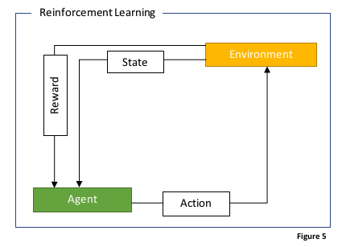

# 2 Research into Applications of ML in medicine

When considering the goal set for the project it was important to examine the software which is currently being used in the medical field and how it incorporated machine learning. This allowed an understanding of how others have approached tasks similar to the intended model. Software that has been designed and software that is in the process of being tested and designed was considered to see the future of ML software. It was important to look at the relevant fields of medicine the software has been designed for, as it gave a clearer understanding of the issues to be considered during the development and design of the project.

## 2.1 Current Applications

### 2.1.1 Epidemic Outbreak Prediction Applications

The main benefit of ML is the ability to go through massive amounts of data and to make critical decisions based on the information it receives. It comes as no surprise that that it is being used and integrated into monitoring and trying to predict outbreaks of diseases around the world. This is especially in the high-risk areas in the world that are affected with diseases like Ebola and Malaria. One of the best examples of how an epidemic outbreak can be monitored is a web-based application called ProMED-mail, which monitors all reported emerging diseases and displays them on a map in real time allowing the user to see what is currently happening in the world. Another example of this technology is an application called HealthMap. HealthMap works by collecting data automatically every hour and analyses it by using ML to identify if the information is current or older, what is the context of the information supplied, if it’s a warning of an impending outbreak or if it is an isolated incident. Based on this information it will create and update a database that pin points all the affected locations on a map. It allows its users to filter the information by a range of categories.

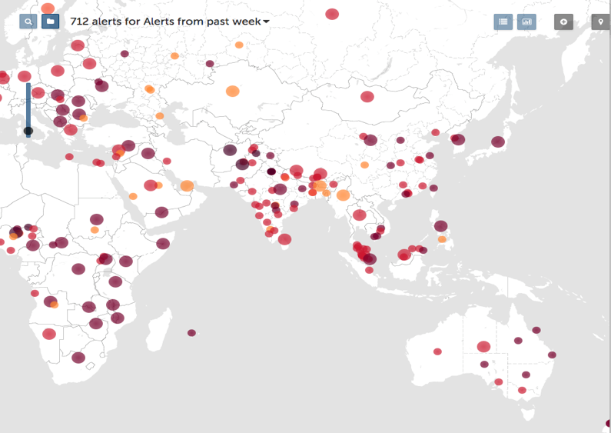

**(http://www.healthmap.org/en/)**

### 2.1.2 Chatbots

Chatbots ML have been around for a while. In the UK - Babylon Health has been working on developing a Chatbot that can interact with its user and asking relevant questions based on the user’s responses. Besides asking questions, the app has the ability based on the user’s answers to determine, if there is cause for a higher degree of concern. When it will recommend a visit to a doctor or recommend over the counter medication again based on the user’s answers to its questions. The application is also able to work with devices such as Apple watches and incorporate the medical data it collects from this device, including the wearer’s heart rate, active time and even cholesterol levels.

### 2.1.3 Oncology Applications

Stanford University researchers have been able to train an algorithm that is capable of diagnosing skin cancers using Convolutional Neural Networks (CNNs). The algorithm they have developed was trained on a database comprising of “nearly 130,000 skin disease images and trained their algorithm to visually diagnose potential cancer.” (Kubta, T. 2017). This application is one of the more impressive uses of ML as it uses images to identify if the affected area may or may not be at risk of being cancerous. This application was inspiration for this project.

### 2.1.4 Pathology Applications

Researchers from Beth Israel Deaconess Medical Centre and Harvard Medical School have worked together to create a machine learning algorithm that is capable of being used for a wide range of applications including speech recognition and image recognition (Prescott, B. 2016). The purpose of the algorithm was to create a model that is capable of identifying the presence or absence of metastatic cancer in a patient’s lymph nodes, which is a common task undertaken by pathologists. Their model’s diagnostic success rate was at 92% which is still 4% less than the human diagnoses rate at 96%. This application has only been used for research at present and did not provide evidence of any clinical applications. However, it remains a good example of what could come from the future development of ML and its adoption into the field of pathology.

## 2.2 Futures Applications

### 2.2.1 Radiology and Radiotherapy Applications

DeepMind an Alphabet Inc., a Google subsidiary has been working with the University College London Hospital (UCLH) to develop a ML algorithm that is capable of distinguishing between healthy and cancerous tissue to improve the efficiency of radiation treatments. The team has described their work as being still in the early stages of research with the use of AI (Google. Researching for tomorrow).

### 2.2.2 Rare Diseases Applications

The improvement of face recognition coupled with the improved quality of cameras on mobile devices has allowed companies to work on developing more advanced applications that will allow for more accurate work functions on more mobile platforms. IBM has been working on developing a method that has potential applications in skin image analysis (IBM Watson Health - Medical Imaging). They are using their Neural network call IBM Watson, but it is currently in the early stages of development as the dataset are complicated and will require a long period to collect.

## 2.3 Obstacles in ML and medicine

### 2.3.1 Data & Regulations

Data is the biggest obstacle on how well the ML model works. If the training data is poorly written or is very small, it will not matter how well the algorithm is written, as it will still turn out a weak model since will have not been able to gain enough knowledge on the data available to create an accurate enough prediction. The quality and quantity of the data isn’t the only issue. Gaining accesses to reliable data is also difficult because when working with medical data there are restrictions and laws which one must abide by. Not all countries treat the retention and dissemination of personal data the same and no one law works globally. In the UK we have three main legislations governing access to patient health records, the first one being The Data Protection Act 1998, which protects the living individuals and authorised persons, the second is The Access to Health Records Act 1990, which governs the access to deceased patient’s records and the final one is The Medical Reports Act 1998, which outlines the rights of individuals to access reports relating to themselves provided by medical practitioners for employment or insurance purposes (NHS Confederation. 2015).

# 3 Information Review

These three articles from the internet are only a small sample of articles showing the interest generated by ML and AI in the field of medicine. “How artificial intelligence is revolutionizing healthcare” (Dickson, B. 2017) is the most relevant, to the project as it delved into the ways in which machine learning has been used in different fields of medicine and not just covered one section, which most of the other articles seem to have focused on.  “On the Cutting Edge: Artificial Intelligence in Medicine” (Sakr, S. 2016) and “An application of machine learning to haematological diagnosis” (Gunčar, G., Kukar, M., Notar, M., Brvar, M., Černelč, P., Notar, M., & Notar, M. 2018) are good at explaining how ML has been integrated into healthcare and how it has improved/enhanced this field. The third article was the best when describing the math’s and algorithms with the use of diagrams and graphs, which the other two articles did not have, as they focused more on the user’s point of view. The second article was the least impressive of the three articles with regards to ML and how it was being used because it was only focused on one topic being AIM, however it did cover the ethical and social challenges that comes to using ML and how this may have an effect on the loss of the human/personal touch in the relationship between patient and physician. The main trend between all three articles is that ML has not removed the human element, being the doctors, from the task as they are still the main decision maker, as ML models are being used mainly to supply suggestions and not diagnoses. The first article also coves what lies ahead and how data security issues are being tightened, but with the introduction of existing tools like Blockchain being adapted to ensure transparency and privacy of patient data. It also covers how with the continued improvement of ML this may one day lead to certain jobs being made redundant and how they feel that the negative side to this development will be the care for patient’s becoming colder but with the benefit being improvements in quality and availability of health services.

# 4 Development of The Applications.

After considering the above applications it was decided to develop medical related applications. More particularly applications relating to pathology and the identification of blood diseases using medical data. An application identifying injuries to a hand was also developed using a lad develop technique, as an example on ML in physiotherapy.

## The Process of classification for predictions

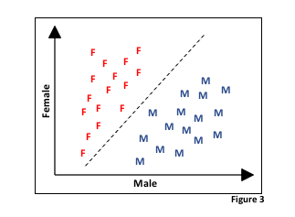

In the initial phase of the project the above model was created to provide a better understanding of how binary classification worked, after viewing an online tutorial (Advent, B. 2017). Here a training sample of 32 names was used. Half (16) of the training samples are female names and the other half are male names. This example of the dataset is two-dimensional, which means each sample has two values associated with it: Female and Male. Using a supervised machine learning algorithm to learn the rule whether the name given is male or female. The difference is represented as a black dashed line that separates the two classes and it will classify new data into these two categories.

### 4.1 Project specifications

The goal was to create prototype application capable of doing the following:

* Able to classify an image or data and make recommendations based on this information.
* Application that can run on a mobile device-in this case an iPad.
* The use of images or a body location detection images and how they can be used to perform a diagnosis.
* Being able to do classification and data search locally without the need of a server or online connection.
* Investigation in options of ML model types
* Being able to identify the difference between different types of images or injuries

### 4.2 Design of my application.

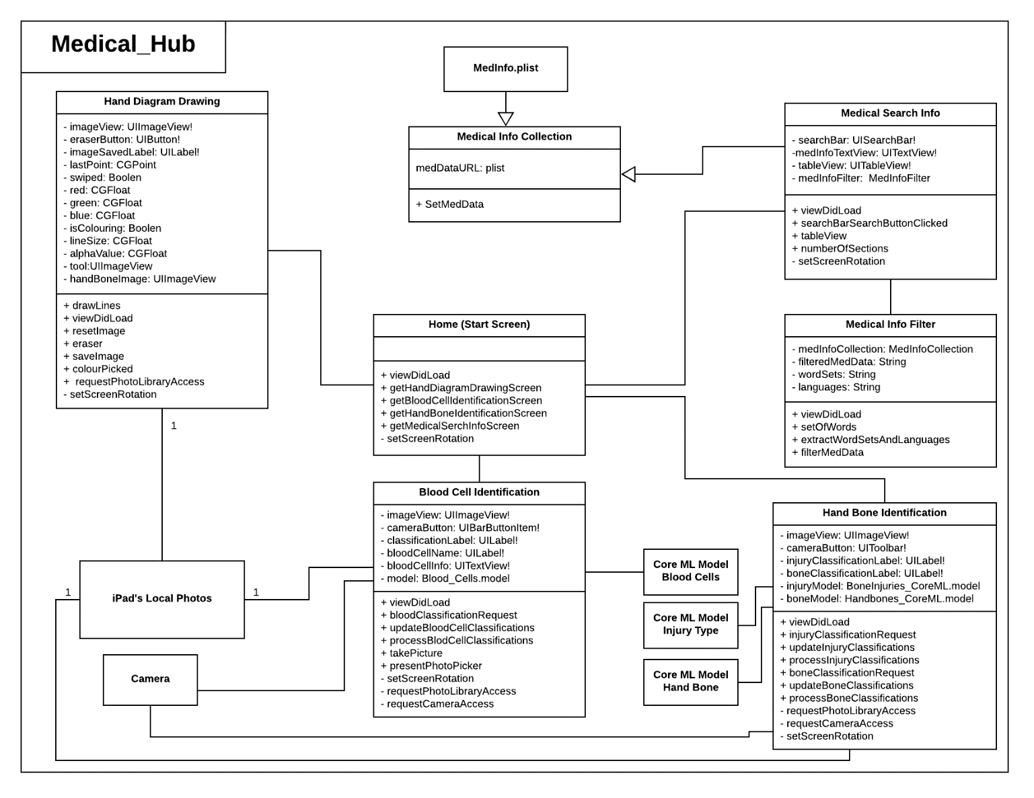The first step in developing the application was to write up a map or a guide to record the goals and ideals for the end program. This helped to keep the development on track. The preferred method here was the use of UML diagrams as this helps to visualise the flow of data and the structure of each class and their attributes and how the operations/methods will work.

UI wireframes was the preferred methods to develop a new application. It allowed one to be in user’s shoes and remove the developer mind-set after working on and designing the UML diagram. It provides for a detailed analysis of the work to see how the user will be interacting with the app and to improve on the development methods. When designing UI, the following factors were considered:

The users will be medical professionals, who are considered to have average knowledge and understanding of how technology works. Since this application runs on an iPad, it is anticipated that they know how to use an iPad, be able to take pictures and navigate around the iPad. Based on this knowledge, the following was incorporated into the design: Use technical medical words, medical images and use average computer technical wording and images such as camera logos, settings icons, etc. Also, as stated the users are professionals so there won’t be a need to intergrade any social media. However, it may be an idea to investigate integrating e-mails allowing the user to send test results to their colleagues for further discussions.

The main data used for the application were images for the ML model which will be used for image recognition. When working with images care was taken that the images are recognisable to the ML model but also the appropriate size to allow the user to recognise which image they have selected. The application has a Natural Language Processing (NLP) section (Advent, B. 2017), which will require a search area and an area where the selected information will be shown.

The app is designed to operate on an iPad, which means the user will be interacting with it using the touch screen. Accordingly, it has been designed with the touch screen buttons of an appropriate size so that users won’t click on the incorrect ones or not be able to see the required button.

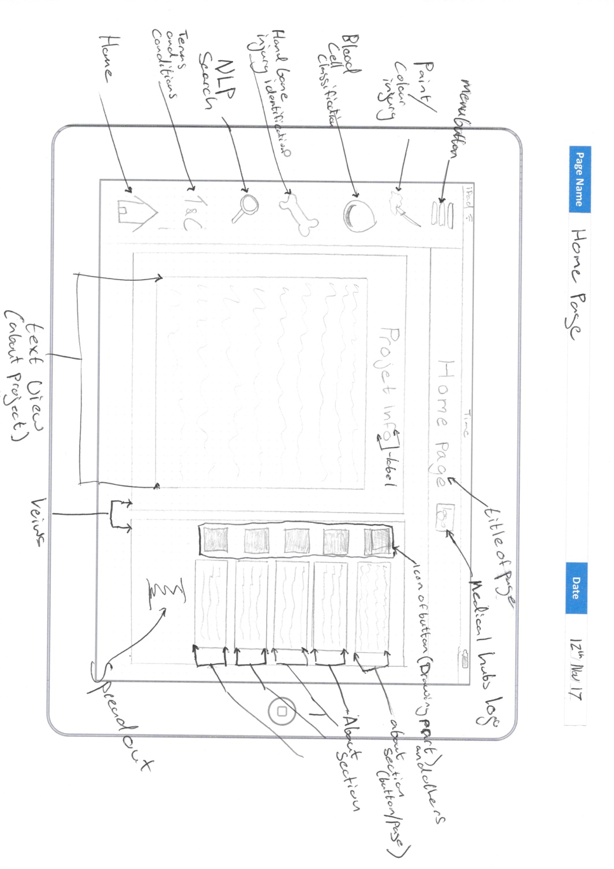As the application is designed for the medical field, neutral colours were used so that the user will not be distracted by a busy background screen and this will also help colour-blind users. The Icons will be clear and won’t leave the user guessing what their purposes or their functionality is.

#### Wireframes drawings

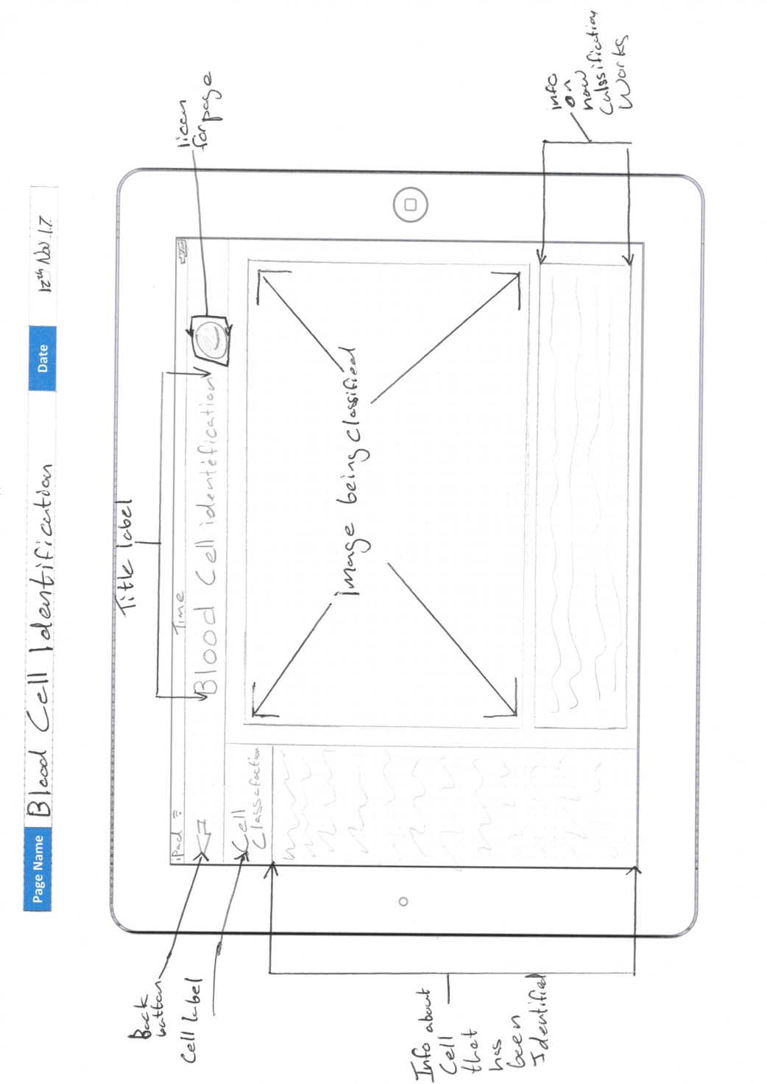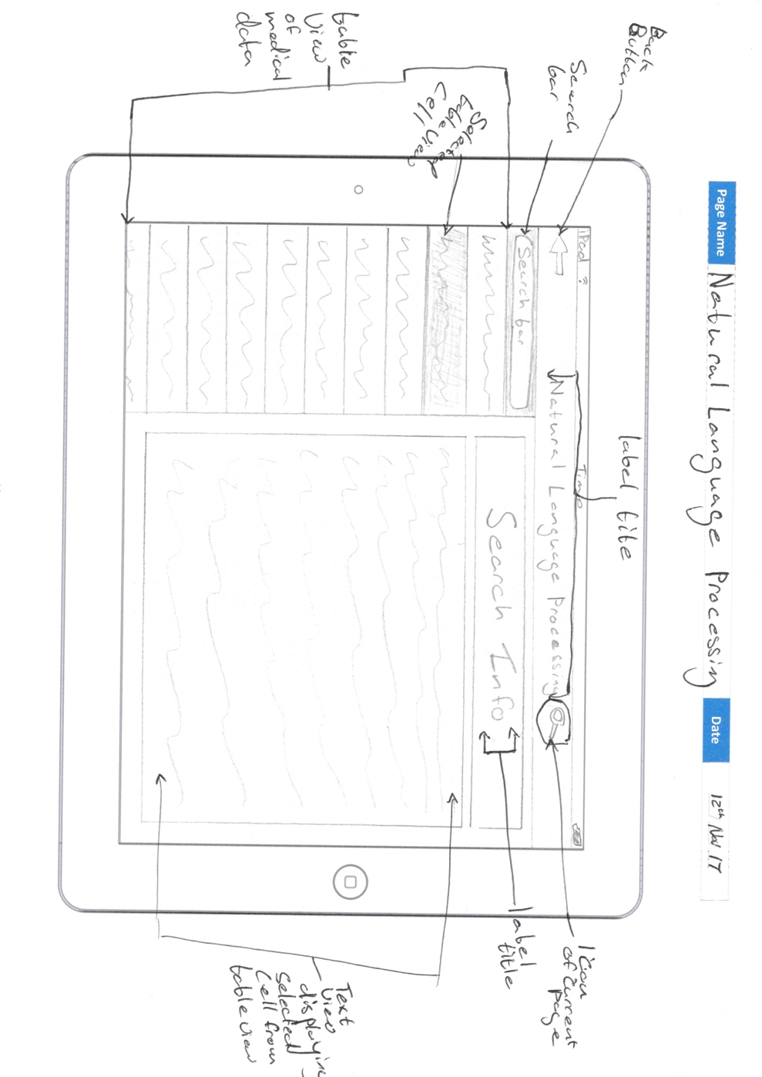

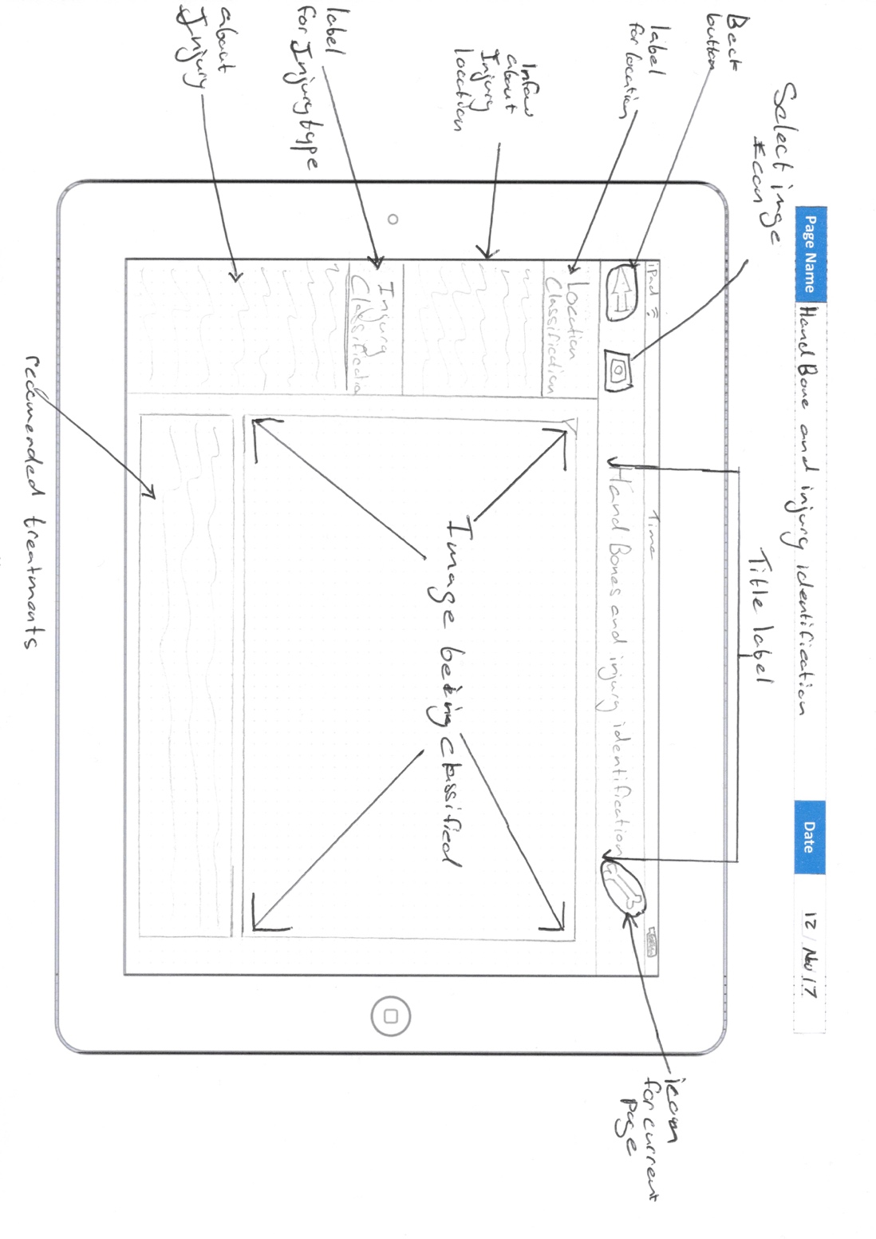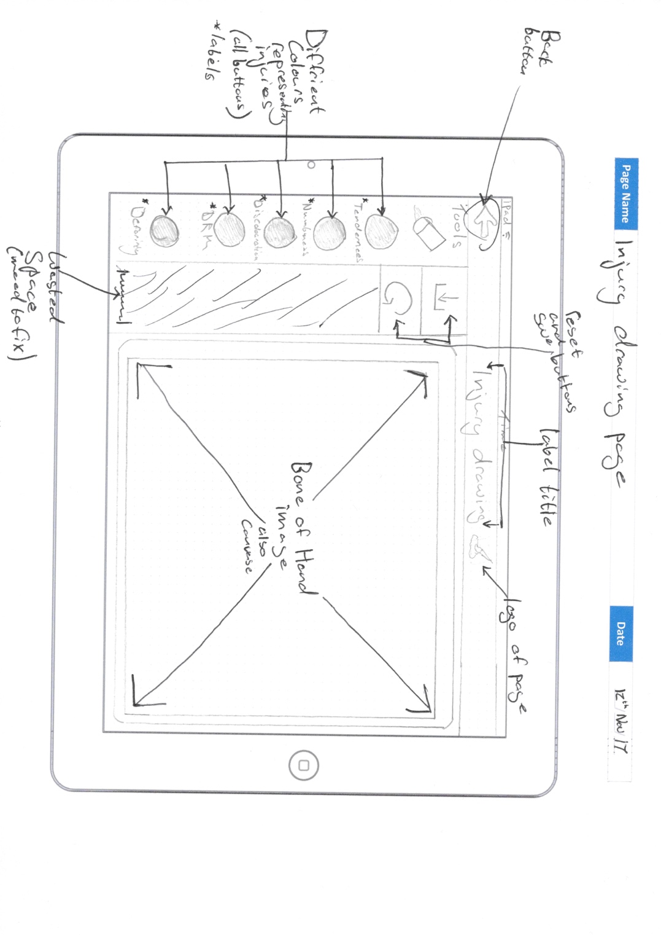

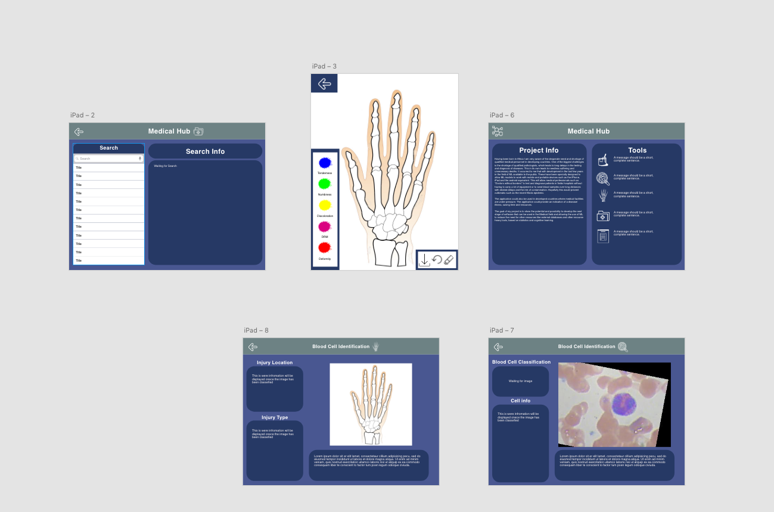Adobe XD is one of the new tools used in the development process. It allowed one to build a simulation of the UI which will be produced for the application and allowed for the app to be demonstrated on an iPad. This gives an idea and feeling of how the applications UI should and will work. This also allows for demonstration to potential users in order to get their opinions on the design and to allow for any changes and improvements. [1]

## 4.4 Management of the application development stage.

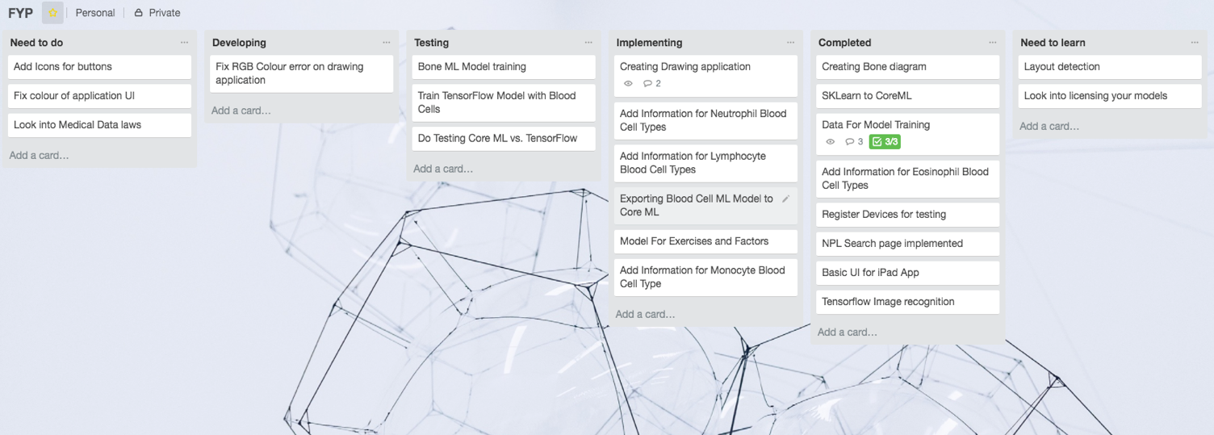For the Agile development part of this project all the different design methodologies as well as all the factors that would have to be considered, for example time, resources and choice of the best methodology that would allow to produce the best outcome were determined. For these reasons an Agile development option was chosen as it allowed for to work in sprints to complete parts of the application and allowed for the development in accordance with available time and resources. One of the tools used to manage the sprints and development was Trello[2], a tool which allowed for the setup of Sprint backlog enabling the placement of each feature on its own card and then to move them down the line of development (Identify, develop, test and implement)

## 4.5 Tools used to develop the project.

Xcode is a development environment for the macOS, designed by Apple for the development of software for macOS, iOS, watchOS, and tvOS (Apple. Swift - Apple Developer). Xcode was used to produce the final application including some demo applications as a part of the gaining an understanding of the Swift language which Xcode uses for the development of the applications. Xcode allows for a drag and drop feature for the development of the UI and to adjust the layout depending on the device and orientation. Xcode also allows for grouping of files for a better MVC layout giving a less cluttered layout. Xcode also gave the opportunity to simulate the app in different environments, by creating a virtual iPad or device. The main issue faced when working with Xcode is version control and that was due to using the older IOS versions that where incompatible with the design of the application. After upgrading to the latest IOS beta the issue was resolved and allowed for the use of the required updated features. These where the only issues caused by Xcode.

Terminal (Mac OS Version) was the main tool used for the development of the ML models as this was the tool used to run python scripts and for the training of the models and to covert those models into models which were compatible with the application. To allow Terminal to operate, other packages had to be installed that allowed it to most importantly run the python scripts and allowed for the dependencies the following scripts needed to be installed, such as numpy, pandas, TensorFlow and Core ML. These are some of the packages that were required to run the scripts. The main issue related to this tool was the installation of these packages. Some of the blog and book recourses initially used had outdated installation references while some only worked with python 2.7 and had not been updated or required more updating and changes to be done to allow it to work with python 3.6. This issue was solved by researching and looking at solutions on Stack Overflow and in the cases relating to TensorFlow’s google documentation was used to learn how to install the package correctly. Another issue was that some package installs required administrative rights. This was easily solved by using the Sudo command, removing the restrictions these errors caused.

## 4.6 Machine learning model frameworks use in the development of the application.

TensorFlow is an open source deep learning neural network, which was create by researchers and engineers from the Google Brain team. TensorFlow was used as a training tool to learn about neural network work (Google TensorFlow). It is easier to learn as it doesn’t require an application to be created to test the model. The added benefit is that the model is already designed by Google and all that would be require in retraining the model is the use of python script. Another reason TensorFlow was chosen is because it was designed by a team working for Google and Core ML was designed by Apple and it would be interesting to compare the quality of the models in the form of the accuracy in identifying the same data. The one small issue resulting from the installation of the TensorFlow modules was that it only installed parts when using the commands that were given on Google’s instructions page on how to install the module, it was better to use TensorFlow’s GitHub repository, as installing it from them directly allowed for the installation of only the requirements needed to create the image classification models.

Turi Create and Core ML are two of the many options available when creating models for ML. One of the first options when working with neural network, was to use the Core ML tools package to convert Sklearn models. This was developed using existing python into ML models. This proved to be not the best option as it had so many different module dependencies like numpy, pandas and others that would course issues if not done correctly. However, Turi allowed for the making of original Core ML models for this application. Turi Create is a tool which was created by Apple to allow for the Core ML models to be made more simply and allow for things like Recommender systems, Image classification, Image similarity, Object detection, Activity classifier (Apple. apple/turicreate). With this help Turi a ML model was created that is capable of image classification like TensorFlow and this give the option of comparing the two, as to see how they compare in accuracy during the testing phase.

## 4.7 Coding Languages used to develop this application.

Python was the OOP language used in this application (Hattem, R. 2016). The benefit of working with Python was that both Core ML and TensorFlow models can be trained and created using Python scripts. The only issue when working with Python code was that when importing TensorFlow it would often throw up errors that it was unable to import. This was due to an issue trying to run the Python script in a standard terminal. To resolve this issue a tool call Docker was used that allowed the running of the script without any import errors.

Swift designed by Apple was another language used in this project (Apple. Swift - Apple Developer). It was developed as an open source programming language designed for the development of applications in Xcode on Apple devices. Swift is currently on its fourth generation and was developed at Swift.org, Swift is an Object Orientated Programming language.

## 4.8 Datasets required for the design of this application.

With the restrictions in the UK relating to the release of medical data, the only datasets that could be obtained were from the US which were currently being used by researchers. All the data used was made anonymously by the researchers. The main type of data that will be required is image datasets that are about 2,000 + images allowing for a solid range of data allowing the models to be trained to their full potential (Shenggan. 2018). When looking at blood cells or cancer cells, only datasets which were well labelled were used due to a lack of medical knowledge by the compiler. Factors taken into consideration when choosing data, where is it from, how was it obtained and what restrictions are there on its uses, as well as any ethical constraints set by the laws.

One of the dataset used was of blood cells which contains about 12,000 images of blood cells and are classified into 4 different cell types (Eosinophil, Lymphocyte, Monocyte, and Neutrophil). This dataset was released under the MIT License and is being used by other teams currently working on identifying and characterizing blood-based diseases using a Real-Time Object Detection application using YOLO (Redmon, J. YOLO: Real-Time Object Detection).

The hand bone dataset was lab created and contains the total of 20,000 images that are classified into 8 classifications; Capitate, Hamate, Lunate, Pisiform, Radius, Scaphoid, Trapezium, Trapezoid, Triquetrum and Ulna (Tarr, C. 2017). Five colours have been used to indicate the different types of injuries (tenderness, numbness, swelling and discoloration, decrease range of motion and deformity) Tarr, C. 2017) that can happen to a hand. This will be use as part of the dataset to train the model to identify injuries and locations on a hand.

For the development of all the applications and test examples three different platforms where used to create and test the apps on during development. The Mac Mini and MacBook Air were used to develop and create the applications and models. This is because mobile devices like iPads and iPhones don’t yet have the capacity to process and create the ML models. If this was attempted on iPads and iPhones it has often been theorised that the devices’ batteries will more than likely be depleted in a matter of seconds. The mobile section focused on iPad devices only thus are likely to be used by the target market. The application could be further developed using a cross platform option such as Xamarin

# 5 Research and PDP

It became apparent at the begin of the project that a lack of experience with machine learning or any of the model software available would be an issue in completing this application successfully. To address this issue online courses and engagement with communities that are working on ML and the different tools required for this project was undertaken. The preferred reference site was lynda.com that had courses ranging from intermediate to advanced allowing for a more detailed learning experience. YouTube also had lessons on how to use TensorFlow (Raval, S. 2016 ), these where created by Google. Other channels covered introductory video tools like Core ML (Ashraf, S. 2017) and TensorFlow which helped to explain how the different tools worked when compared to one another. As a part of the research and learning some test applications were created which are not limited to working on IOS, but also on a Mac

## 5.1 Summary of skills/knowledge that where required to be developed/learnt to create this application:

|  |  |
| --- | --- |
| Skill | Points |
| Python | * The use of Python and algorithms * How to use packages use like Core ML, TensorFlow, Numpy and others * The different methods needed to creating ML graphs * Referencing other files and folder locations * How to install Python on macOS using terminal |
| Swift | * Using new types of imports * Referencing other Swift files * Management of data * Changing default layout orientation * Implementing Core ML files * User privacy settings * Using tags effectively |
| Core ML | * Being able to build affective models * Using image and text type datasets * Working with multiple label types * How data effects Core ML model’s performance * Auto layout skill improvement * More efficient if statements |
| TensorFlow | * How to retrain models * How to create image recognition models * How to install packages from directly GitHub * Trouble shooting and practical thinking * Communication skills with peers |
| macOS | * Terminal skills and commands improvements * Short cuts and keyboard commands * HDD navigational improvement * Better understanding of User restrictions when using Sudo and installing packages * Better version control |
| Investigation | * Effective searching when attempting to solve and issue with code or applications * Looking for appropriate datasets * Research for learning materials * Submersing information for quick study and development * Engaging with communities when conducting investigation * Identifying quality between second and first-hand information |
| Medical | * The different types of Blood Cells and their uses in the human body and how they are vulnerable to diseases and how those diseases are identified * Ethical issues when working with patient data and how bad data could affect the way an issue is treated and the fallout from that * IDC and what it looks like and how to train my models to identify signs * Hand bone structure and the different types of injuries it can receive |
| Documentation | * Effective layouts and the flow of information * Displaying research effectively and without repetition of information * When to use diagrams to help explain process more clearly * The use of abbreviations to reduce the amount of words used repetitively * The use of relevant foot notes |
| Development | * Agile development process understanding * Planning steps to produce the deliverables * Backing up and commenting on work during development * Sprints and how best to use them * Trello and how to use it more effectively when running a project |
| Legal | * Understanding the way in which medical information is stored and the legal implications * Data Protection Acts that protect a patient’s data deceased or alive * How my model’s mistakes may lead to legal action if it was in a real environment * How laws on medical information differs from country to country and on the countries view on what can be ethically and legally done. |

# 5.2 Comparison of the Models created.

## 5.2.1 Test details

Before running the tests: - For the test details that the application will be using the Blood Cell datasets and will be showing both in the Core ML and TensorFlow models data, they will be shown Images they have never seen before during training to allow for more honest answers. The main things that will be looked at in this test is the models label classification that it will give the image and the accuracy of the classification. The test will consist of 21 tests and the average of those test will be collected at the end and compared. There is an exception for this test to have varied answers and for this reason the models will not be limited to displaying the most relevant classification but rather display all four labels ranked on accuracy and this will only be compared to the accuracy from the known classifications. The results have been set out in the bellow table.

### TensorFlow

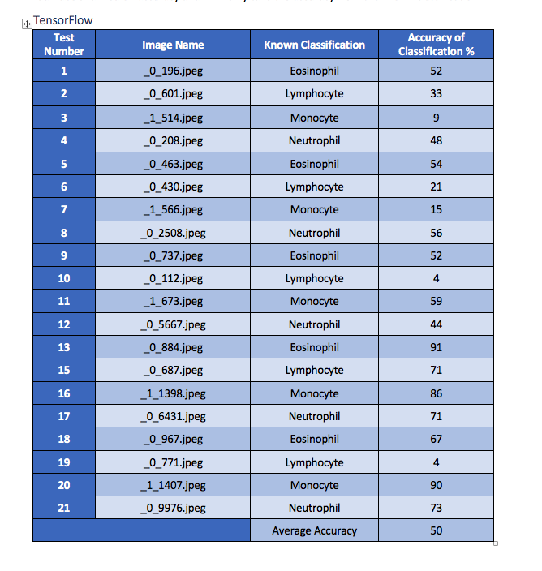

### Core ML

### 5.2.2 TensorFlow Vs. Core ML

It is important to reiterate the fact that all images were selected at random for these tests, with both models being given the same images to make it a fair test. When designing the test, a totally different outcome was expected. It was expected that TensorFlow would get the higher accuracy average and Core ML to be the weaker of the two models. As can be seen from the tables above and the below summary that was not the case. Looking at the data collected from the test we can see that TensorFlow scored below Core ML in all the blood cell types and in some cases had less than half of Core ML’s Accuracy Avg. The main reason that these results are shocking is that TensorFlow has been around longer and has gone through more development than Core ML and the script used to train the model was designed to run 10,000 times making it a more efficient model. The end training accuracy was marked at 85% which would be a more reasonable result during the test. When training the Core ML model, was only trained 1,000 times and scored an 89% accuracy on the training data. The underlining issue is not with the way the models are trained and since both the models work on a similar method for training image recognition, which leads one to believe the issue may come with the query script used for TensorFlow or the possibility that it may be using outdated methods and algorithms. The other issue is that the model being retrained is called Inception v4 that was trained by Google on 100,000 images with more than a thousand categories designed to identify more detailed objects like flowers, cars and other everyday objects where the Core ML model is designed especially for Blood Cell identification and not for any other image classification. An improvement, if this test where to be redone, would be rebuild another TensorFlow model that wasn’t being retrained from an example, as it would be interesting to see if that was the main cause for the bad results. It is felt that query script was not at fault as the outcome is depicted from the model produced.

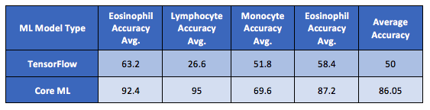

# 6 Medical Hub (Main Deliverable)

The main deliverable I will be handing over is my Medical Hub application which was designed for use on an iPad. The Medical Hub application is made up of multiple parts. This application is capable of image and colour recognition. It can classify blood cells into one of these four labels Eosinophil, Lymphocyte, Monocyte, and Neutrophil. The resultant Blood Cell type is than displayed after classification. Another part is that of being able to Identify images that can be created using the Injury Drawing section allowing the user to colour in part of the Hand diagram and then saving the image before submitting it for hand bone and injury Identification. This works similar to the Blood cell identification, except that it will use two models to classify the injury location and type of injury. An added feature is the symptoms Natural Language Processing (NLP) ( Advent, B. 2017), which I was taught during my PDP and found this it be quite an interesting tool. This could be added as a way for doctors to search symptoms, without worrying about the terminology they used such as bleeding to bleed, as NLP will look for all words related to the term inputted.

## 6.1 Home

For this section reference is made to HomeViewController.swift file. Coding wise there isn’t much besides the method (**Lines 26 - 33**) which I used to make sure that the application is set landscape and does not have the ability to rote. This may be redundant as the default layout has been set as landscape. However, this code was retained as a security measure as the default layout could be changed and it may course issues with the layout, which will affect the quality of the app and its usability. Focusing on the UI I have implemented the buttons that will direct the user to the different pages and have created a description for each using Text Views, since labels won’t be sufficient to write out the whole description for each button. I have added some information on the right to describe the main purpose of the application.

## 6.2 Injury Drawing

For this section I will be referring to InjuryDrawingViewController.swift file. This section of my application is essentially a basic colouring application where I have designed an area that the user is capable creating their own image for the Hand Bone and injury Identification model to use. This section allows the user to use their finger or stylus to colour in part of the hand diagram highlighting all the areas which are affected and with the colour representing the type of injury. I have added buttons on the side to allow the user to switch between them with ease and have implemented an eraser feature to remove all unwanted mistakes. The user can save their images but to do so a request will be made to the user by the application before the image they have created can be saved. There is also a reset button if the user would like to restart at any point. The layout has been designed to avoid any unwanted mistakes caused by bumping a button by mistake. With regard to coding I have had to implement a lot, to allow for the drawing and saving of imagers. I have also used methods like reverencing tags (**Lines 123 - 140**) on all my colour buttons to reduce the amount of coding needed to change colours.

## 6.3 Blood Cell Identification

For this section I will be referring to BloodCellViewController.swift which is the file for this section of Cocoa Touch Class, with the additional file being CGImagePropertyOrientation+UIImageOrientation.swift (Apple. Classifying Images with Vision and Core ML, n.d.) which is used by other Cocoa Touch Class files. In this section of the application the user will be allowed to submit blood cell images from the photo library or by taking a picture using the iPad’s camera, then allowing them to submit it to the application which will use the Core ML model Blood_Cells.mlmodel to classify the type of cell it is and then display the relevant information. The sections of code I would like to highlight is **lines 26 – 40** which is the Core ML setup. This part is crucial if the model fails to load the application will display an error on the console during development and debugging. The next section I would like to highlight is the Classification process which takes place on **lines 60 – 96**, once the classification of the image has been made, an if statement will check what was the classification result and display the relevant data. This section will also send the percentage accuracy to the classificationLabel. For this part of the application I worked off an example Apple designed as Core ML example and I used that to develop it into a more relevant programmed that would not only identify blood cell images but also one that is capable of displaying information about the image it identifies.

## 6.4 Hand Bone and injury Identification

For this section I will be referring to BoneViewController.swift which is the file for this section Cocoa Touch Class, with the additional file being CGImagePropertyOrientation+UIImageOrientation.swift (Apple. Classifying Images with Vision and Core ML, n.d.). This part of the application has a very similar code to the Blood Cell Identification section as they are built on the same code base. However, this time instead of using one Core ML model this application section will take advantage of two. One to classify the location on the hand were the injury is located and the second model is the identification of the classification of the injury.

## 6.5 Natural Language Processing

In this section I will be referring to as MedicalSearchViewController.swift, MedInfoFilter.swift and MedInfoCollection.swift. This time the main focus isn’t on the View Controller (VC) but rather the additional file (MedInfoFilter) that it references. For this part of the application I use a rather new feature call NSLinguisticTagger (**Found on Line 45**), which helps to provide a uniform interface to a variety of natural language processing functionality with the added benefit of supporting many different languages. So, if the app was presented another language it would not affect its ability to conduct searches. VC mainly focuses on the layout and the displaying of data in the table list and when searched the VC will pass the query onto the MedInfoFilter which will use the NSLinguisticTagger and the VC will then display the filtered list that it collects the data defined by the MedInfoCollection file which would be the MedInfo.plist. Once the user selects their option the VC will display the data in the text view.

## 6.6 Application (Medial HUB) Evaluations

The consensus from the review was that they like the layout They felt that the app was easy to read, and they could get an idea what each apart of the app did by looking at the buttons and without much guess work. The main thing commented on was the layout of the buttons as it was felt that the colouring in diagram button should be closer to the hand injury identification tool and this has since been changed.

The technical side of the application they were impressed and found the classification of both hand and blood not to take as long as expected and enjoyed the ability to choose from the photo library or the use of the camera, allowing them not to be limited to one source of images.

The main issue they pointed out with the drawing application was that they would have like the ability to zoom in on the picture to make the colouring more accurate. The other issue that was highlighted was the accuracy of the hand bone identification as it often got some of the drawing miss classified when locating an injury type. The most interesting part the users found was the accuracy of the blood cell identifier as it got all the test samples right, even when they tried to trick it by giving it bad images using the camera.

The main thing taken away with from the reviews is that the app still requires a bit of housekeeping before being releasing to the public or into a beta stage.

# 7 Critical Reflection

## 7.1 Project & Deliverables

I will class the overall outcome of the project as a success. I was able to produce an application that can identify blood cells and able to identify location of injuries and injury types on a hand. However after working with the application during development and testing, I feel that more could still be done with the development of the models, as I would not feel ethically comfortable with releasing the application to the public or medical sectors as the results given from this application are correct a high percentage of the time, but if the application was to give an incorrect answer this could lead to a misdiagnosis resulting in a death, as the blood diseases I chose to use are fatal if not treated correctly. With regards to the Bone and injury model they are both still very rough and the dataset was created and not collected, which makes the dataset not as realistic and more lab grown. In the future to get the more realistic dataset I would create the colour injury tool into its own app and give it to medical professionals who will use the app to input the injury data and submit it anonymously to me to use for an improved dataset. However, the legal issues with this may be the down fall as I would have to go through many legal barriers to use the data. To get around this issue I would preferably partner with a medical establishment or department like the other teams have done to allow me to conduct my research without this hindrance and allow me to have medical professionals to consult with about more technical medical issues.

## 7.2 Research

Following the research, I undertook, I have improved my understanding of how ML is currently being used in the medical industry and how it is shaping the way we think about resolving medical issues. As well as how ML models can be developed to help reduce errors and identify trends. The issue I had with my research was my technical skills when I first started as I had no experience with such complex algorithms and terminologies that are being used in the papers and blogs. I think if I was to carry on with this application and research into a thesis I would need to learn more about the terminologies and attend a few lectures and conferences about ML and engaging more with the communities and teams working on similar projects, getting to know how they work and how they developed their skills. The other issue I had with the research was that it can quickly becomes outdated like most technology it is developing at a rapid rate and this often causes issues when working with examples that may no longer produce the same outcome. To get around this issue I ignored any examples older than two years as they often didn’t work when I tried them during early stages of development and I would search for updated blogs or papers reflecting these issues and topics.

## 7.3 PDP

Out of my whole project I am most happy about my PDP as I had to learn many new things at the start of my project. I had to gain the knowledge to do new things like algorithms, advance Python, ML and other skills which I had to develop. The main part of my planning was to find and work with reliable sources that were either cited by ML companies or by reliable sources. The main issue with my development was that it took longer than expected to gain this knowledge and at times I found that information I had learnt three months ago was no longer relevant or was outdated. Most of the applications that have already been created where done by teams of people working together and at times I wished that I had other people to consult with when I had issues with this application or who would have understood the underlying issues I was facing. I found that I learnt better with visual sources as I could see the whole development from start to end and then adapt the information I needed, so I adapted my PDP to incorporate more visual sources like Lynda.com and YouTube, which helped to speed up my learning process.

## 7.4 Success of Deliverables and Future Development

As stated previously this application is not ready to be released to the public because it’s not ready for decisions that have such serous consequences, as even though the Core ML model scored 86.05% on the tests we just need that outliner to be a part of the 13.95% and not being identified correctly. Accordingly, I would like to add more information to the database and train it to have a 100% detection rate. The success of the deliverable is much like the success of the projects that were reviewed at the start of the paper, there are parts of the application where it achieves outstanding results like the Blood Cell identification were it is able to achieve a high success rate in correct classification, but in part of the application like the bone and injury identification the success rate is significantly lower than the failure rate and because of this, it would be more of a hindrance than a assistance when being used. NPL is a great addition and work up to a point. NPL isn’t designed to work with medical words and terminology, so often the words searched will be the only return information that contains that word and not plurals or related words. The drawing part of the application is acceptable and is by no means reinventing the wheel, but it fulfills its purpose and allows the user to create their image to use later in the bone and injury classification. It can defiantly do with some improvements like a click to colour in a whole bone to speed up the process. In the end of the project it was successful in achieve the goal of being able to do the task. I would like to develop a more accurate model for both the bone and injury as they are both my own datasets, by adding of data to it from other medical resources. I would consider separating the apps into different medical fields so that it can be tailored to suit the users and stop the application becoming over populated with data and information not relevant to every user. I would like to develop the bone and injury models to cover more than just the hand bones but the whole body and include muscles and organs reflecting the injuries they can receive. This would help doctors who would be treating patients with injuries or ailments that they are not familiar with in countries with very little or no medical resources where medical personal like doctors without borders treat patients.

## 8 Conclusion

Now as I look at my project that I am about to hand in I feel that it was been a difficult but exciting road traveled to get to this point, I had to overcome my lack of knowledge of ML models but at the end I can say that it was a success, with an acceptable accuracy rate. My application can recognize different blood cells images from datasets and hand bone injuries. I wanted to show that medical applications could benefit from AI and I set out to prove that these medical applications can be developed to help in counties with limited medical resources and I believe with some more work this and other applications like it can be developed to help all the people of this world rich or poor.

# 9 References & Appendix

## 9.1 Abbreviation list

|  |  |
| --- | --- |
| Abbreviation | Full Name/ Word |
| ML | Machine Learning |
| AI | Artificial intelligence |
| IDC | Invasive Ductal Carcinoma |
| MIT | Massachusetts Institute of Technology |
| OOP | Object-oriented programming |
| VC | View Controller |

## 

## 9.2 Libraries

|  |  |
| --- | --- |
| Libraries | Install command |
| Python (pip) | sudo easy_install pip |
| Numpy | pip install -U numpy |
| Pandas | pip install -U pandas |
| Turi Create | pip install -U turicreate |
| TensorFlow | pip install -U tensorflow |
| Core ML Tools | pip install -U coremltools |
| Sklearn | pip install -U sklearn |

## 9.3 Lynda.com Courses Links

|  |  |
| --- | --- |
| Course Title | Link |
| iOS App Development: Core ML | <https://www.lynda.com/iOS-tutorials/iOS-App-Development-Core-ML/636123-2.html> |
| Building and Deploying Deep Learning Applications with TensorFlow | <https://www.lynda.com/Google-TensorFlow-tutorials/Building-Deploying-Applications-TensorFlow/601800-2.html?org=shu.ac.uk> |

# 10 Bibliography

## 10.1 Online Recourses

Advent, B. (2017). *iOS App Development: Core ML*. *Lynda.com - from LinkedIn*. Retrieved 11 April 2018, from https://www.lynda.com/iOS-tutorials/iOS-App-Development-Core-ML/636123-2.html

Apple. *apple/turicreate*. *GitHub*. Retrieved from https://github.com/apple/turicreate

Apple. *Classifying Images with Vision and Core ML | Apple Developer Documentation*. *Developer.apple.com*. Retrieved from https://developer.apple.com/documentation/vision/classifying_images_with_vision_and_core_ml

Apple. *Swift - Apple Developer*. *Developer.apple.com*. Retrieved from https://developer.apple.com/swift/

Ashraf, S. (2017). *Image Classification In iOS Apps Using Turi Create And CoreML*. *C-sharpcorner.com*. Retrieved from https://www.c-sharpcorner.com/article/image-classification-in-ios-apps-using-turi-create-and-coreml/

Bekhit, A. (2018). *Creating a Custom Core ML Model Using Python and Turi Create*. *Appcoda.com*. Retrieved from https://www.appcoda.com/core-ml-model-with-python/

Brownlee, J. (2016). *Supervised and Unsupervised Machine Learning Algorithms - Machine Learning Mastery*. *Machine Learning Mastery*. Retrieved from https://machinelearningmastery.com/supervised-and-unsupervised-machine-learning-algorithms/

Castle, N. (2017). *Supervised vs. Unsupervised Machine Learning*. *Datascience.com*. Retrieved from https://www.datascience.com/blog/supervised-and-unsupervised-machine-learning-algorithms

Codella, N. (2016). *Identifying skin cancer with computer vision - IBM Blog Research*. *IBM Blog Research*. Retrieved from https://www.ibm.com/blogs/research/2016/11/identifying-skin-cancer-computer-vision/

Dickson, B. (2017). *How artificial intelligence is revolutionizing healthcare*. *The Next Web*. Retrieved 12 April 2018, from https://thenextweb.com/artificial-intelligence/2017/04/13/artificial-intelligence-revolutionizing-healthcare/

Faggella, D. (2018). *7 Applications of Machine Learning in Pharma and Medicine*. *TechEmergence*. Retrieved 4 January 2018, from https://www.techemergence.com/machine-learning-in-pharma-medicine/

Geitgey, A. (2017). *Building and Deploying Deep Learning Applications with TensorFlow*. *Lynda.com*. Retrieved 11 April 2018, from https://www.lynda.com/Google-TensorFlow-tutorials/Building-Deploying-Applications-TensorFlow/601800-2.html?org=shu.ac.uk

Google. *Researching for tomorrow | DeepMind*. *DeepMind*. Retrieved from https://deepmind.com/applied/deepmind-health/working-partners/health-research-tomorrow/

Google. *TensorFlow*. *TensorFlow*. Retrieved from https://www.tensorflow.org/

IMB. *IBM Watson Health - Medical Imaging*. *IBM Watson Health*. Retrieved from https://www.ibm.com/watson/health/imaging

Kubta, T. (2017). *Artificial intelligence used to identify skin cancer | Stanford News*. *Stanford News*. Retrieved from https://news.stanford.edu/2017/01/25/artificial-intelligence-used-identify-skin-cancer

MIT. *MIT Clinical Machine Learning Group*. *Clinicalml.org*. Retrieved from http://clinicalml.org/research.html

Mooney, P. (2018). *Blood Cell Images | Kaggle*. *Kaggle.com*. Retrieved from https://www.kaggle.com/paultimothymooney/blood-cells

NHS Confederation. (2015). *Legislation and guidance relating to medical records explained by House of Commons Library*. *Nhsconfed.org*. Retrieved from http://www.nhsconfed.org/resources/2015/10/legislation-and-guidance-relating-to-medical-records-explained-by-house-of-commons-library

Poon, H., Quirk, C., & Wen-tau Yih, S. *Project Hanover*. *Hanover.azurewebsites.net*. Retrieved from http://hanover.azurewebsites.net/

Prescott, B. (2016). *Better Together*. *Hms.harvard.edu*. Retrieved from https://hms.harvard.edu/news/better-together

Puget, J. (2016). *What Is Machine Learning? (IT Best Kept Secret Is Optimization)*. *Ibm.com*. Retrieved from https://www.ibm.com/developerworks/community/blogs/jfp/entry/What_Is_Machine_Learning?lang=en

Raval, S. (2016). *Build a TensorFlow Image Classifier in 5 Min*. *YouTube*. Retrieved from https://www.youtube.com/watch?v=QfNvhPx5Px8&t=126s&index=2&list=PLcMS9fT_r8XX9TSvnqnMQ3gYXfkt_JAud

Redmon, J. *YOLO: Real-Time Object Detection*. *Pjreddie.com*. Retrieved from https://pjreddie.com/darknet/yolo/

Rizvi, M. (2017). *How to build your first Machine Learning model on iPhone - Apple CoreML*. *Analytics Vidhya*. Retrieved from https://www.analyticsvidhya.com/blog/2017/09/build-machine-learning-iphone-apple-coreml/

Sennaar, K. (2018). *Machine Learning for Medical Diagnostics - 4 Current Applications -*. *TechEmergence*. Retrieved from https://www.techemergence.com/machine-learning-medical-diagnostics-4-current-applications

Shenggan. (2018). *Shenggan/BCCD_Dataset*. *GitHub*. Retrieved from https://github.com/Shenggan/BCCD_Dataset

Sunny, Y. (2018). *Swift 100 Days: Project 24 - Portrait? Landscape? How to allow rotate in one vc?*. *Medium*. Retrieved from https://medium.com/@sunnyleeyun/swift-100-days-project-24-portrait-landscape-how-to-allow-rotate-in-one-vc-d717678301c1

Tarr, C. (2017). *Hand Injuries: Types of Common Injuries & Trauma*. *eMedicineHealth*. Retrieved from https://www.emedicinehealth.com/hand_injuries/article_em.htm#hand_injury_causes

Babylon. *Online Doctor Consultations & Advice | babylon health*. *babylon health*. Retrieved from https://www.babylonhealth.com/

## 10.2 Books

Hattem, R. (2016). *Mastering Python*. Birmingham, UK: Packt Publishing.

Raschka, S., & Olson, R. (2016). *Python machine learning* (pp. 1-20). Birmingham: Packt Publishing.

## 10.3 Journal

Gunčar, G., Kukar, M., Notar, M., Brvar, M., Černelč, P., Notar, M., & Notar, M. (2018). An application of machine learning to haematological diagnosis. *Scientific Reports*, *8*(1). http://dx.doi.org/10.1038/s41598-017-18564-8

Sakr, S. (2016). On the Cutting Edge: Artificial Intelligence in Medicine. *Medical Students’ Osler Society And The Board Of Curators Of The Osler Library Of The History Of Medicine Essay Contest*, 2-11. Retrieved from https://www.mcgill.ca/library/files/library/sakr_surya_2016.pdf

1. For a better view please see additional file Medical Hub UI Test.xd
2. For Full version please see trello.com/b/O5Pco3mP/fyp